BHAI PARMANAND INSTITUTE OF BUSINESS STUDIES

DEPARTMENT OF COMPUTER APPLICATION



PROJECT ON “BILLING SYSTEM”

MCA Third Semester

Submitted To: Submitted By:
Deepak Sir Nikhil Rajbhar
02611404420

INDEX

- Introduction
- Objective
- Functionality
- S/H Requirment
- DFD
- ER- digram
- Form shot

ACKNOWLEDGEMENT

I express my sincere gratitude and thanks to Mr. Pravir Chitre (Python faculty) for providing me the excellent opportunity to do a project on Billing System and providing me with all the essential required for the completion and enhancement of this project.

INRODUCTION

The project “Billing System” is an application to automate the process of ordering and billing of a “Departmental store”.

OBJECTIVE

This project will serve the following objectives:-
- Add and maintain records of available products.
- Add and maintain customer details.
- Add and maintain description of new products.
- Provides a convenient solution of billing pattern.
- Make an easy to use environment for users and customers.

FUNCTIONALITY

Created a simple Billing software which can perform basic arithmetic operation like addition, tax calculation and record customer details, bill no., and purchased products details etc depending upon the user input.

REQUIRMENT

- Hardware Requirment

- Ram 2GB minimum.

- Processor AMD processor 4000+ series minimum.

- Hard Disk 15GB minimum.

- Monitor 17” color

- Software Requirment

- Operating System Win 7,8,10.

- Python programming.

DFD
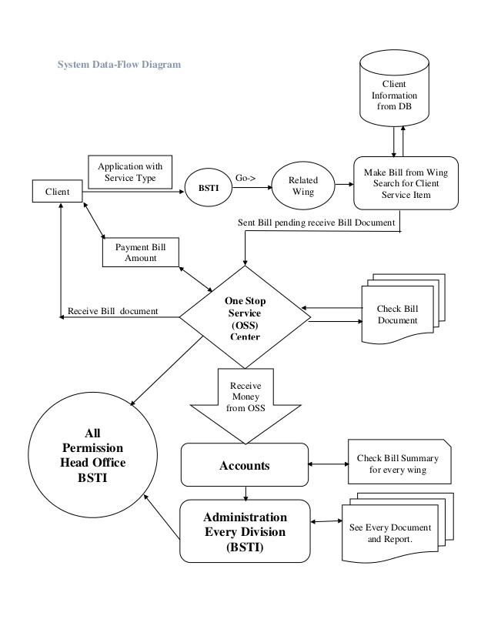

ER- DIGRAM

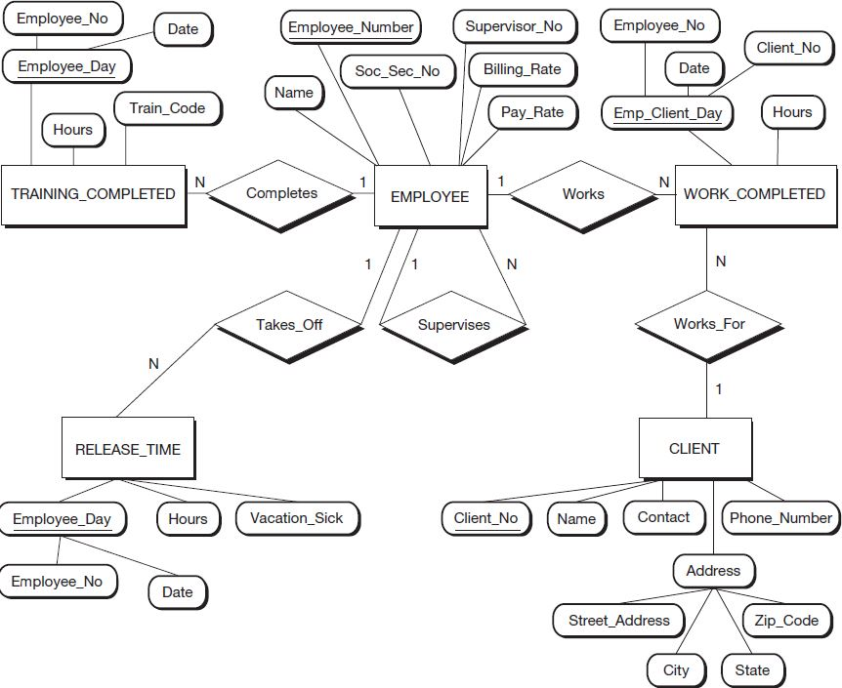

Form Shot

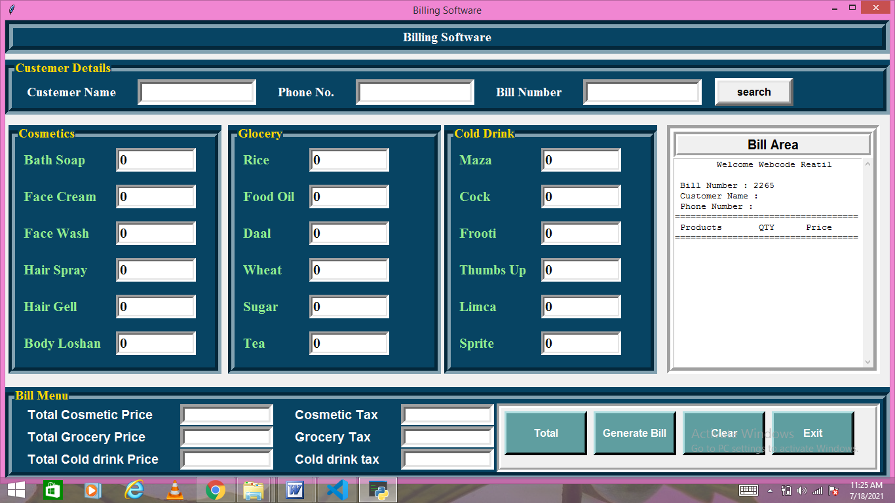

Source code
from tkinter import*
import math,random,os
from tkinter import messagebox
class Bill_App:
def __init__(self,root):
self.root=root
self.root.geometry("1350x700+0+0")
self.root.title("Billing Software")
bg_color="#074463"
title=Label(self.root,text="Billing Software",bd=12,relief=GROOVE,bg=bg_color,fg="white",font=("times new roman",15,"bold"),pady=2).pack(fill=X)
#============Variables==============
#===========Cosmatic================
self.soap=IntVar()
self.face_cream=IntVar()
self.face_wash=IntVar()
self.spray=IntVar()
self.gell=IntVar()
self.loshan=IntVar()
#============grocery==============
self.rice=IntVar()
self.food_oil=IntVar()
self.daal=IntVar()
self.wheat=IntVar()
self.sugar=IntVar()
self.tea=IntVar()
#=============Cold Drink===========
self.maza=IntVar()
self.cock=IntVar()
self.frooti=IntVar()
self.thumbsup=IntVar()
self.limca=IntVar()
self.sprite=IntVar()

#=========Total Product Price & Tax Variables=====
self.cosmetic_price=StringVar()
self.grocery_price=StringVar()
self.cold_drink_price=StringVar()

self.cosmetic_tax=StringVar()
self.grocery_tax=StringVar()
self.cold_drink_tax=StringVar()

#==============Customer============
self.c_name=StringVar()
self.c_phone=StringVar()

self.bill_no=StringVar()
x=random.randint(1000,9999)
self.bill_no.set(str(x))
self.search_bill=StringVar()

#================Custemer Detail Frame============

F1=LabelFrame(self.root,bd=10,relief=GROOVE,text="Custemer Details",font=("times new roman",15,"bold"),fg="gold",bg=bg_color)
F1.place(x=0,y=60,relwidth=1)
cname_lbl=Label(F1,text="Custemer Name",bg=bg_color,fg="white",font=("times new roman",15,"bold")).grid(row=0,column=0,padx=20,pady=5)
cname_txt=Entry(F1,width=15,textvariable=self.c_name,font="arial 15",bd=7,relief=SUNKEN).grid(row=0,column=1,pady=5,padx=10)
cphn_lbl=Label(F1,text="Phone No.",bg=bg_color,fg="white",font=("times new roman",15,"bold")).grid(row=0,column=2,padx=20,pady=5)
cphn_txt=Entry(F1,width=15,textvariable=self.c_phone,font="arial 15",bd=7,relief=SUNKEN).grid(row=0,column=3,pady=5,padx=10)

cbill_lbl=Label(F1,text="Bill Number",bg=bg_color,fg="white",font=("times new roman",15,"bold")).grid(row=0,column=4,padx=20,pady=5)
cbill_txt=Entry(F1,width=15,textvariable=self.search_bill,font="arial 15",bd=7,relief=SUNKEN).grid(row=0,column=5,pady=5,padx=10)

bill_btn=Button(F1,text="search",command=self.find_bill,width=10,bd=7,font="arial 12 bold").grid(row=0,column=6,padx=10)

#==========Cosmetics Frame==================
F2=LabelFrame(self.root,bd=10,relief=GROOVE,text="Cosmetics",font=("times new roman",15,"bold"),fg="gold",bg=bg_color)
F2.place(x=5,y=160,width=325,height=380)

bath_lbl=Label(F2,text="Bath Soap",font=("times new roman",16,"bold"),bg=bg_color,fg="lightgreen").grid(row=0,column=0,padx=10,pady=10,sticky="w")
bath_txt=Entry(F2,width=10,textvariable=self.soap,font=("times new roman",16,"bold"),bd=5,relief=SUNKEN).grid(row=0,column=1,padx=10,pady=10)

Face_cream_lbl=Label(F2,text="Face Cream",font=("times new roman",16,"bold"),bg=bg_color,fg="lightgreen").grid(row=1,column=0,padx=10,pady=10,sticky="w")
Face_cream_txt=Entry(F2,width=10,textvariable=self.face_cream,font=("times new roman",16,"bold"),bd=5,relief=SUNKEN).grid(row=1,column=1,padx=10,pady=10)

Face_w_lbl=Label(F2,text="Face Wash",font=("times new roman",16,"bold"),bg=bg_color,fg="lightgreen").grid(row=2,column=0,padx=10,pady=10,sticky="w")
Face_w_txt=Entry(F2,width=10,textvariable=self.face_wash,font=("times new roman",16,"bold"),bd=5,relief=SUNKEN).grid(row=2,column=1,padx=10,pady=10)

Hair_s_lbl=Label(F2,text="Hair Spray",font=("times new roman",16,"bold"),bg=bg_color,fg="lightgreen").grid(row=3,column=0,padx=10,pady=10,sticky="w")
Hair_s_txt=Entry(F2,width=10,textvariable=self.spray,font=("times new roman",16,"bold"),bd=5,relief=SUNKEN).grid(row=3,column=1,padx=10,pady=10)

Hair_g_lbl=Label(F2,text="Hair Gell",font=("times new roman",16,"bold"),bg=bg_color,fg="lightgreen").grid(row=4,column=0,padx=10,pady=10,sticky="w")
Hair_g_txt=Entry(F2,width=10,textvariable=self.gell,font=("times new roman",16,"bold"),bd=5,relief=SUNKEN).grid(row=4,column=1,padx=10,pady=10)

Body_lbl=Label(F2,text="Body Loshan",font=("times new roman",16,"bold"),bg=bg_color,fg="lightgreen").grid(row=5,column=0,padx=10,pady=10,sticky="w")
Body_txt=Entry(F2,width=10,textvariable=self.loshan,font=("times new roman",16,"bold"),bd=5,relief=SUNKEN).grid(row=5,column=1,padx=10,pady=10)

#==========Glocery Frame==================
F3=LabelFrame(self.root,bd=10,relief=GROOVE,text="Glocery",font=("times new roman",15,"bold"),fg="gold",bg=bg_color)
F3.place(x=340,y=160,width=325,height=380)

g1_lbl=Label(F3,text="Rice",font=("times new roman",16,"bold"),bg=bg_color,fg="lightgreen").grid(row=0,column=0,padx=10,pady=10,sticky="w")
g1_txt=Entry(F3,width=10,textvariable=self.rice,font=("times new roman",16,"bold"),bd=5,relief=SUNKEN).grid(row=0,column=1,padx=10,pady=10)

g2_lbl=Label(F3,text="Food Oil",font=("times new roman",16,"bold"),bg=bg_color,fg="lightgreen").grid(row=1,column=0,padx=10,pady=10,sticky="w")
g2_txt=Entry(F3,width=10,textvariable=self.food_oil,font=("times new roman",16,"bold"),bd=5,relief=SUNKEN).grid(row=1,column=1,padx=10,pady=10)

g3_lbl=Label(F3,text="Daal",font=("times new roman",16,"bold"),bg=bg_color,fg="lightgreen").grid(row=2,column=0,padx=10,pady=10,sticky="w")
g3_txt=Entry(F3,width=10,textvariable=self.daal,font=("times new roman",16,"bold"),bd=5,relief=SUNKEN).grid(row=2,column=1,padx=10,pady=10)

g4_lbl=Label(F3,text="Wheat",font=("times new roman",16,"bold"),bg=bg_color,fg="lightgreen").grid(row=3,column=0,padx=10,pady=10,sticky="w")
g4_txt=Entry(F3,width=10,textvariable=self.wheat,font=("times new roman",16,"bold"),bd=5,relief=SUNKEN).grid(row=3,column=1,padx=10,pady=10)

g5_lbl=Label(F3,text="Sugar",font=("times new roman",16,"bold"),bg=bg_color,fg="lightgreen").grid(row=4,column=0,padx=10,pady=10,sticky="w")
g5_txt=Entry(F3,width=10,textvariable=self.sugar,font=("times new roman",16,"bold"),bd=5,relief=SUNKEN).grid(row=4,column=1,padx=10,pady=10)

g6_lbl=Label(F3,text="Tea",font=("times new roman",16,"bold"),bg=bg_color,fg="lightgreen").grid(row=5,column=0,padx=10,pady=10,sticky="w")
g6_txt=Entry(F3,width=10,textvariable=self.tea,font=("times new roman",16,"bold"),bd=5,relief=SUNKEN).grid(row=5,column=1,padx=10,pady=10)

#==========Cold Drink Frame==================
F4=LabelFrame(self.root,bd=10,relief=GROOVE,text="Cold Drink",font=("times new roman",15,"bold"),fg="gold",bg=bg_color)
F4.place(x=670,y=160,width=325,height=380)

c1_lbl=Label(F4,text="Maza",font=("times new roman",16,"bold"),bg=bg_color,fg="lightgreen").grid(row=0,column=0,padx=10,pady=10,sticky="w")
c1_txt=Entry(F4,width=10,textvariable=self.maza,font=("times new roman",16,"bold"),bd=5,relief=SUNKEN).grid(row=0,column=1,padx=10,pady=10)

c2_lbl=Label(F4,text="Cock",font=("times new roman",16,"bold"),bg=bg_color,fg="lightgreen").grid(row=1,column=0,padx=10,pady=10,sticky="w")
c2_txt=Entry(F4,width=10,textvariable=self.cock,font=("times new roman",16,"bold"),bd=5,relief=SUNKEN).grid(row=1,column=1,padx=10,pady=10)

c3_lbl=Label(F4,text="Frooti",font=("times new roman",16,"bold"),bg=bg_color,fg="lightgreen").grid(row=2,column=0,padx=10,pady=10,sticky="w")
c3_txt=Entry(F4,width=10,textvariable=self.frooti,font=("times new roman",16,"bold"),bd=5,relief=SUNKEN).grid(row=2,column=1,padx=10,pady=10)

c4_lbl=Label(F4,text="Thumbs Up",font=("times new roman",16,"bold"),bg=bg_color,fg="lightgreen").grid(row=3,column=0,padx=10,pady=10,sticky="w")
c4_txt=Entry(F4,width=10,textvariable=self.thumbsup,font=("times new roman",16,"bold"),bd=5,relief=SUNKEN).grid(row=3,column=1,padx=10,pady=10)

c5_lbl=Label(F4,text="Limca",font=("times new roman",16,"bold"),bg=bg_color,fg="lightgreen").grid(row=4,column=0,padx=10,pady=10,sticky="w")
c5_txt=Entry(F4,width=10,textvariable=self.limca,font=("times new roman",16,"bold"),bd=5,relief=SUNKEN).grid(row=4,column=1,padx=10,pady=10)

c6_lbl=Label(F4,text="Sprite",font=("times new roman",16,"bold"),bg=bg_color,fg="lightgreen").grid(row=5,column=0,padx=10,pady=10,sticky="w")
c6_txt=Entry(F4,width=10,textvariable=self.sprite,font=("times new roman",16,"bold"),bd=5,relief=SUNKEN).grid(row=5,column=1,padx=10,pady=10)

#===============Bill Area======================
F5=Frame(self.root,bd=10,relief=GROOVE)
F5.place(x=1010,y=160,width=325,height=380)
bill_title=Label(F5,text="Bill Area",font="arial 15 bold",bd=7,relief=GROOVE).pack(fill=X)
scrol_y=Scrollbar(F5,orient=VERTICAL)
self.txtarea=Text(F5,yscrollcommand=scrol_y.set)
scrol_y.pack(side=RIGHT,fill=Y)
scrol_y.config(command=self.txtarea.yview)
self.txtarea.pack(fill=BOTH,expand=1)

#=============Button Frame=================

F6=LabelFrame(self.root,bd=10,relief=GROOVE,text="Bill Menu",font=("times new roman",15,"bold"),fg="gold",bg=bg_color)
F6.place(x=0,y=560,relwidth=1,height=140)
m1_lbl=Label(F6,text="Total Cosmetic Price",bg=bg_color,fg="white",font=("time new roman",14,"bold")).grid(row=0,column=0,padx=20,pady=1,sticky="w")
m1_txt=Entry(F6,width=18,textvariable=self.cosmetic_price,font="arial 10 bold",bd=7,relief=SUNKEN).grid(row=0,column=1,padx=10,pady=1)

m2_lbl=Label(F6,text="Total Grocery Price",bg=bg_color,fg="white",font=("time new roman",14,"bold")).grid(row=1,column=0,padx=20,pady=1,sticky="w")
m2_txt=Entry(F6,width=18,textvariable=self.grocery_price,font="arial 10 bold",bd=7,relief=SUNKEN).grid(row=1,column=1,padx=10,pady=1)

m3_lbl=Label(F6,text="Total Cold drink Price",bg=bg_color,fg="white",font=("time new roman",14,"bold")).grid(row=2,column=0,padx=20,pady=1,sticky="w")
m3_txt=Entry(F6,width=18,textvariable=self.cold_drink_price,font="arial 10 bold",bd=7,relief=SUNKEN).grid(row=2,column=1,padx=10,pady=1)

c1_lbl=Label(F6,text="Cosmetic Tax",bg=bg_color,fg="white",font=("time new roman",14,"bold")).grid(row=0,column=2,padx=20,pady=1,sticky="w")
c1_txt=Entry(F6,width=18,textvariable=self.cosmetic_tax,font="arial 10 bold",bd=7,relief=SUNKEN).grid(row=0,column=3,padx=10,pady=1)

c2_lbl=Label(F6,text="Grocery Tax",bg=bg_color,fg="white",font=("time new roman",14,"bold")).grid(row=1,column=2,padx=20,pady=1,sticky="w")
c2_txt=Entry(F6,width=18,textvariable=self.grocery_tax,font="arial 10 bold",bd=7,relief=SUNKEN).grid(row=1,column=3,padx=10,pady=1)

c3_lbl=Label(F6,text="Cold drink tax",bg=bg_color,fg="white",font=("time new roman",14,"bold")).grid(row=2,column=2,padx=20,pady=1,sticky="w")
c3_txt=Entry(F6,width=18,textvariable=self.cold_drink_tax,font="arial 10 bold",bd=7,relief=SUNKEN).grid(row=2,column=3,padx=10,pady=1)

btn_F=Frame(F6,bd=7,relief=GROOVE)
btn_F.place(x=740,width=585,height=105)

total_btn=Button(btn_F,command=self.total,text="Total",bg="cadetblue",fg="white",bd=5,pady=15,width=11,font="arial 12 bold").grid(row=0,column=0,padx=5,pady=5)
Gbill_btn=Button(btn_F,text="Generate Bill",command=self.bill_area,bg="cadetblue",fg="white",bd=5,pady=15,width=11,font="arial 12 bold").grid(row=0,column=1,padx=5,pady=5)
Clear_btn=Button(btn_F,text="Clear",command=self.clear_data,bg="cadetblue",fg="white",bd=5,pady=15,width=11,font="arial 12 bold").grid(row=0,column=2,padx=5,pady=5)
Exit_btn=Button(btn_F,text="Exit",command=self.Exit_app,bg="cadetblue",fg="white",bd=5,pady=15,width=11,font="arial 12 bold").grid(row=0,column=3,padx=5,pady=5)
self.welcome_bill()

def total(self):
self.c_s_p=self.soap.get()*40
self.c_fc_p=self.face_cream.get()*120
self.c_fw_p=self.face_wash.get()*60
self.c_hs_p=self.spray.get()*180
self.c_hg_p=self.gell.get()*140
self.c_bl_p=self.loshan.get()*180

self.total_cosmetic_price=float(
self.c_s_p+
self.c_fc_p+
self.c_fw_p+
self.c_hs_p+
self.c_hg_p+
self.c_bl_p
)
self.cosmetic_price.set("Rs. "+str(self.total_cosmetic_price))
self.c_tax=round((self.total_cosmetic_price*0.05),2)
self.cosmetic_tax.set("Rs. "+str(self.c_tax))

self.g_r_p=self.rice.get()*40
self.g_f_p=self.food_oil.get()*120
self.g_d_p=self.daal.get()*60
self.g_w_p=self.wheat.get()*180
self.g_s_p=self.sugar.get()*140
self.g_t_p=self.tea.get()*180

self.total_grocery_price=float(
self.g_r_p+
self.g_f_p+
self.g_d_p+
self.g_w_p+
self.g_s_p+
self.g_t_p

)
self.grocery_price.set("Rs. "+str(self.total_grocery_price))
self.g_tax=round((self.total_grocery_price*0.1),2)
self.grocery_tax.set("Rs. "+str(self.g_tax))

self.d_m_p=self.maza.get()*60
self.d_c_p=self.cock.get()*60
self.d_f_p=self.frooti.get()*50
self.d_t_p=self.thumbsup.get()*45
self.d_l_p=self.limca.get()*40
self.d_s_p=self.sprite.get()*60

self.total_drinks_price=float(
self.d_m_p+
self.d_c_p+
self.d_f_p+
self.d_t_p+
self.d_l_p+
self.d_s_p
)
self.cold_drink_price.set("Rs. "+str(self.total_drinks_price))
self.d_tax=round((self.total_drinks_price*0.05),2)
self.cold_drink_tax.set("Rs. "+str(self.d_tax))

self.Total_bill=float(
self.total_cosmetic_price+
self.total_grocery_price+
self.total_drinks_price+
self.c_tax+
self.g_tax+
self.d_tax
)

def welcome_bill(self):
self.txtarea.delete('1.0',END)
self.txtarea.insert(END,"\tWelcome Webcode Reatil\n")
self.txtarea.insert(END,f"\n Bill Number : {self.bill_no.get()}")
self.txtarea.insert(END,f"\n Customer Name : {self.c_name.get()}")
self.txtarea.insert(END,f"\n Phone Number : {self.c_phone.get()}")
self.txtarea.insert(END,f"\n===================================")
self.txtarea.insert(END,f"\n Products\t\tQTY\t Price")
self.txtarea.insert(END,f"\n===================================")

def bill_area(self):
if self.c_name.get()=="" or self.c_phone.get()=="":
messagebox.showerror("Error","Customer details are must")
elif self.cosmetic_price.get()=="Rs. 0.0" and self.grocery_price.get()=="Rs. 0.0" and self.cold_drink_price.get()=="Rs. 0.0":
messagebox.showerror("Error","No product purchased")
else:
self.welcome_bill()
#======cosmetics======
if self.soap.get()!=0:
self.txtarea.insert(END,f"\n Bath Soap\t\t{self.soap.get()}\t {self.c_s_p}")
if self.face_cream.get()!=0:
self.txtarea.insert(END,f"\n Face Cream\t\t{self.face_cream.get()}\t {self.c_fc_p}")
if self.face_wash.get()!=0:
self.txtarea.insert(END,f"\n Face Wash\t\t{self.face_wash.get()}\t {self.c_fw_p}")
if self.spray.get()!=0:
self.txtarea.insert(END,f"\n Spray\t\t{self.spray.get()}\t {self.c_hs_p}")
if self.gell.get()!=0:
self.txtarea.insert(END,f"\n Hair Gell\t\t{self.gell.get()}\t {self.c_hg_p}")
if self.loshan.get()!=0:
self.txtarea.insert(END,f"\n Body Loshan\t\t{self.loshan.get()}\t {self.c_bl_p}")

#======Grocery======
if self.rice.get()!=0:
self.txtarea.insert(END,f"\n Rice\t\t{self.rice.get()}\t {self.g_r_p}")
if self.food_oil.get()!=0:
self.txtarea.insert(END,f"\n Food Oil\t\t{self.food_oil.get()}\t {self.g_f_p}")
if self.daal.get()!=0:
self.txtarea.insert(END,f"\n Daal\t\t{self.daal.get()}\t {self.g_d_p}")
if self.wheat.get()!=0:
self.txtarea.insert(END,f"\n Wheat\t\t{self.wheat.get()}\t {self.g_w_p}")
if self.sugar.get()!=0:
self.txtarea.insert(END,f"\n Sugar\t\t{self.sugar.get()}\t {self.g_s_p}")
if self.tea.get()!=0:
self.txtarea.insert(END,f"\n Tea\t\t{self.tea.get()}\t {self.g_t_p}")

#======Drinks======
if self.maza.get()!=0:
self.txtarea.insert(END,f"\n maza\t\t{self.maza.get()}\t {self.d_m_p}")
if self.cock.get()!=0:
self.txtarea.insert(END,f"\n Cock\t\t{self.cock.get()}\t {self.d_c_p}")
if self.frooti.get()!=0:
self.txtarea.insert(END,f"\n Frooti\t\t{self.frooti.get()}\t {self.d_f_p}")
if self.thumbsup.get()!=0:
self.txtarea.insert(END,f"\n Thumbsup\t\t{self.thumbsup.get()}\t {self.d_t_p}")
if self.limca.get()!=0:
self.txtarea.insert(END,f"\n Limca\t\t{self.limca.get()}\t {self.d_l_p}")
if self.sprite.get()!=0:
self.txtarea.insert(END,f"\n Sprite\t\t{self.sprite.get()}\t {self.d_s_p}")

self.txtarea.insert(END,f"\n...................................")
if self.cosmetic_tax.get()!="Rs. 0.0":
self.txtarea.insert(END,f"\n Cosmetic Tax\t\t {self.cosmetic_tax.get()}")
if self.grocery_tax.get()!="Rs. 0.0":
self.txtarea.insert(END,f"\n Grocery Tax\t\t {self.grocery_tax.get()}")
if self.cold_drink_tax.get()!="Rs. 0.0":
self.txtarea.insert(END,f"\n Cold drink Tax\t\t{self.cold_drink_tax.get()}")

self.txtarea.insert(END,f"\n Total Bill\t\t Rs. {str(self.Total_bill)}")
self.txtarea.insert(END,f"\n...................................")
self.save_bill()

def save_bill(self):
op=messagebox.askyesno("Save Bll","Do you want to save the Bill")
if op>0:
self.bill_data=self.txtarea.get('1.0',END)
f1=open("bills/"+str(self.bill_no.get())+".txt","w")
f1.write(self.bill_data)
f1.close()
messagebox.showinfo("Saved",f"Bill no. : {self.bill_no.get()} Saved Successfully")
else:
return
def find_bill(self):
present="no"
for i in os.listdir("bills/"):
if i.split('.')[0]==self.search_bill.get():
f1=open(f"bills/{i}","r")
self.txtarea.delete('1.0',END)
for d in f1:
self.txtarea.insert(END,d)
f1.close()
present="yes"
if present=="no":
messagebox.showerror("Error","Invalid Bill No.")

def clear_data(self):
op=messagebox.askyesno("Clear","Do you really want to clear")
if op>0:

#===========Cosmatic================
self.soap.set(0)
self.face_cream.set(0)
self.face_wash.set(0)
self.spray.set(0)
self.gell.set(0)
self.loshan.set(0)
#============grocery==============
self.rice.set(0)
self.food_oil.set(0)
self.daal.set(0)
self.wheat.set(0)
self.sugar.set(0)
self.tea.set(0)
#=============Cold Drink===========
self.maza.set(0)
self.cock.set(0)
self.frooti.set(0)
self.thumbsup.set(0)
self.limca.set(0)
self.sprite.set(0)

#=========Total Product Price & Tax Variables=====
self.cosmetic_price.set("")
self.grocery_price.set("")
self.cold_drink_price.set("")

self.cosmetic_tax.set("")
self.grocery_tax.set("")
self.cold_drink_tax.set("")

#==============Customer============
self.c_name.set("")
self.c_phone.set("")

self.bill_no.set("")
x=random.randint(1000,9999)
self.bill_no.set(str(x))
self.search_bill.set("")
self.welcome_bill()

def Exit_app(self):
op=messagebox.askyesno("Exit","Do you really want to exit")
if op>0:
self.root.destroy()

root=Tk()
obj = Bill_App(root)
root.mainloop()

CONCLUSION

This was my project of system design about “Billing system”.devlopment of this system takes a lot of efforts.
I think this system gave a lot of satisfaction.

Thank you

